Website Research
As part of AS1.3 you must complete research and analysis of existing websites, evaluating each website to establish your design ideas.
Complete 5 Website Research examples from http://www.designfridge.co.uk/

At the bottom of this research task you have to complete a Final Evaluation on how you can use certain aspects of your Website Research to establish your design ideas.

Website Print Screen | Evaluate and make notes on each website, how have they used the following;  Design Principles; Sequence, Alignment, Balance, Proximity, Contrast and Harmony.  Navigation, Buttons, Imagery, Animation.
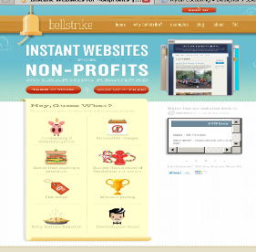 | Sequence - the website has sequence using its sidebars. Its menu buttons reminisce its content. The banner is a let down though because the light blue colour is not suitable in my opinion  Harmony – the menu colour harmonise with the content colour of the website.
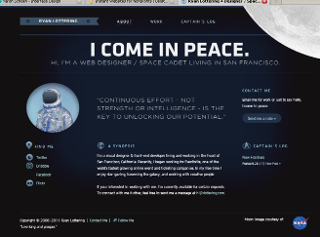 | Harmony - The use of the black space in the website is a very good representation of the theme of their website  Proximity – alignment is a key feature in this website because they utilise and limit paragraphs to fit their screen
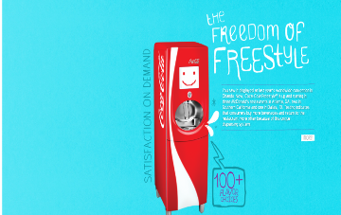 | Contrast - The graphics in this website is very superb in a way of the details they have used. The colour blue space contrast the colour red coke colour  Alignment and proximity – the text in this website is centred to implement its connection to the image and the image colours complements the text colours  I might have to reconsider using the fonts in this website
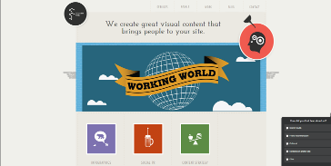 | Alignment and proximity – The flash-feature animation in this website is used very well in the terms of bringing the viewer the main points in the website  Contrast and Harmony – the use of the grey colour utilises the use of the font colour in the menu of the website while the white space renders a contrasting colour for the website
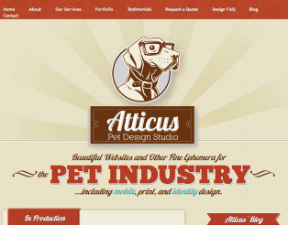 | Harmony and Balance – the use of red, light brown and white for this website complements the dark brown colour in the title image of the website. The briefness of the information on the homepage is excellent in webdesign  Proportion – the picture of a dog in its homepage gives the viewer the instant idea that this website is about pet’s webpages
Final Evaluation; I could use one or two of the fonts featured in these websites and also some the flash animation and function that the last website uses. In observation to these websites, it has come to my knowledge that most of their headings are aligned at the centre while the paragraphs are aligned left. Sequence, easy navigation and proportion are the main things found at a successful website.

